DROWSINESS DETECTION SYSTEM

**BY**

**ABISHEKH KUMAR**

(Admission No. 19JE0048)



THESIS SUBMITTED TO

DEPARTMENT OF MECHANICAL ENGINEERING INDIAN INSTITUTE OF TECHNOLOGY (ISM), DHANBAD – 826004

**MAY, 2024**

For the partial fulfilment of the degree of **BACHELOR OF TECHNOLOGY**

**Supervisor: Dr. Zafar Alam**

**CERTIFICATE**

This is to certify that the thesis titled “**Drowsiness Detection System**” being submitted by **Mr. Abishekh Kumar (Admission no: 19JE0048)** for the award of the degree of Bachelor of Technology in the Department of Mechanical Engineering of Indian Institute of Technology (Indian School of Mines), Dhanbad is a record of bonafide research work carried out by him under my supervision. In my opinion, the thesis is worthy of consideration for the award of the degree of Bachelor of Technology in accordance with the regulations of the institute. The results presented in the thesis have not been submitted to any other university or institute for the award of any degree.

[Signature of Supervisor]

Dr. Zafar Alam

Assistant Professor

Department of Mechanical Engineering,

Indian Institute of Technology (ISM) Dhanbad-826004, Jharkhand, INDIA

**Date: 08/05/2024**

**DECLARATION**

I hereby declare that the work which is being presented in this dissertation entitled “Drowsiness Detection System” in partial fulfillment of the requirements for the award of the degree of B.Tech in Mechanical Engineering is an authentic record of my own work carried out during the period from Aug 2023 to May 2024 under the supervision of Dr Zafar Alam Department of Mechanical Engineering, Indian Institute of Technology (ISM) Dhanbad, Jharkhand, India.

I acknowledge that I have read and understood the UGC (Promotion of Academic Integrity and Prevention of Plagiarism in Higher Educational Institutions) Regulations, 2018. These Regulations were published in the Indian Official Gazette on 31st July, 2018.

I confirm that this Dissertation has been checked for plagiarism using the online plagiarism checking software provided by the Institute. I herewith confirm that the Dissertation has less than 10% similarity according to the plagiarism checking software’s report and meets the MoE/UGC Regulations as well as the Institute's rules for plagiarism.

I further declare that no portion of the dissertation or its data will be published without the Institute's or Guide's permission. I have not previously applied for any other degree or award using the topics and findings described in my dissertation.

(Signature of the Student)

Name of the Student: Abishekh Kumar

Admission No.: 19JE0048

Department : Mechanical Engineering

**ACKNOWLEDGEMENTS**

I would like to express my deep sense of gratitude to **Dr. Zafar Alam**, Assistant Professor, Department of Mechanical Engineering, IIT (ISM) Dhanbad, India for introducing me to the field of machine learining and the guidance he has provided to me throughout this project.

Also, I would like to acknowledge **Prof. Sachin Kumar Singh,** (DUGC), Department of

Mechanical Engineering, IIT (ISM) Dhanbad for permitting me to work on this project. Lastly, I would like to show my immense gratitude to all the people who were directly or indirectly involved during the period of this project.

Abishekh Kumar

**Date: 08/05/2024**

**Abstract**

Now a days, there has been a significant increase in traffic accidents caused by driver fatigue, which results in several fatalities. The driver loses control when he falls asleep, resulting in an accident. This occurs when the driver is unable to manage his vehicle at high speeds on the road. Driver inattention is a major cause of most car accidents. Driver weariness caused by sleep deprivation or sleep disorders is a major factor in the increasing frequency of accidents on today's roadways. Drowsy driver warning systems can serve as the foundation for a system that could reduce accidents caused by driving drowsiness. This project can generate a model which can prevent such accidents. To avoid this, we devised a very simple and cost-effective solution. When a driver falls asleep on this project. Keywords: Traffic Accidents, Control, Warning, Vehicle, Sleep.**List of Figures**

|  |  |  |
| --- | --- | --- |
| **Sl. No.** | **Figure** | **Page no.** |
| **1.** | Figure 3.1 68 Facial landmarks | **xiii** |
| **2.** | Figure 3.2 Landmarks on closed and open eye | **xiv** |
| **3.** | Figure 3.3: Facial landmarks associated with mouth | **xiv** |
| **4.** | Figure 3.4: Flowchart showing entire process of Drowsiness Detection System | **xiv** |
| **5.** | Figure 4.1 App detecting face | **xvii** |
| **6.** | Figure 4.2 Alerting while drowsy | **xvii** |
| **7.** | Figure 4.3 Hardware setup | **xvii** |
| **8.** | Figure 4.4 Face detection using camera | **xvii** |
| **9.** | Figure 4.5 Body posture is not stable | **xvii** |
| **10.** | Figure 4.6 Yawn detected with drowsiness | **xvii** |

**CONTENTS**

|  |  |  |
| --- | --- | --- |
| **Content Details** |  | **Page No.** |
| **Title Page** |  | i |
| **Certificate** | | ii |
| **Declaration** |  | iii |
| **Acknowledgements** | | iv |
| **Abstract** |  | v |
| **List of Figures** | | vi |
| **Contents** |  | vii |
|  |  |  |
| **Chapter 1** | **Introduction** | **ix-x** |
|  |  |  |
| ***1.1*** | ***Introduction*** | ix |
| ***1.2*** | ***Problem Statement of the Thesis*** | x |
| ***1.3*** | ***Objectives of the Thesis*** | x |
|  |  |  |
| **Chapter 2** | **Literature Survey** | **xi-xii** |
|  |  |  |
| ***2.1*** | ***Introduction (Sub-section)*** | xi |
|  | 2.1.1 Literature Survey (Sub-sub-section) | xii |
| *2.2* | Future Scope of the Research Work | xii |
|  |  |  |
| **Chapter 3** | **Materials and Experimental Techniques/Methodology** | **xiii-xiv** |
|  |  |  |
| ***3.1*** | ***Introduction*** | xiii |
| ***3.2*** | ***Summary*** | xiv |
|  |  |  |
| **Chapter 4** | **Result** | **xv** |
| ***4.1*** | ***Introduction*** | xv |
| ***4.2*** | ***Results and Discussion*** | xvi |
|  | 4.2.1 Sub-sub-section | xvi |
| ***4.3*** | ***Summary*** | xvii |
| **Chapter 5** | **Conclusions and Future Scope** | **xviii** |
| ***5.1*** | ***Conclusions*** | xvii |
| ***5.2*** | ***Future Scope of the Work*** | xix |
|  | **References** | **xx** |

**Chapter 1**

**1.1 Introduction**

Road safety is a significant public health issue, and a cause of injuries and fatalities. According to a report by the Ministry of Road Transport and Highways Transport Research Wing, road accidents claimed 1,53,972 lives and harmed 3,84,448 people in 2021. Unfortunately, the age range that is most severely hit by road accidents is 18 to 45 years old, which accounts for almost 67 percent of all accidental deaths. A crucial problem that causes numerous car accidents annually is driver fatigue. To address this issue there is need built a Drowsiness detection system that can enhance the safety of drivers and passenger on road.

The German claims that Road Safety Council (DVR), one in every four fatalities resulting from highway traffic a result of driver fatigue. from highway traffic a result of driver fatigue.When a driver nods off behind the wheel, they lose control of the vehicle, which frequently results in a collision with another automobile or stationary objects. Checking the driver's level of tiredness can help prevent these tragic accidents. It has been generally reported that monitored utilising the subsequent techniques: measures based on vehicles several indicators, such as lane changes, steering wheel movement, and pressure The accelerator pedal, among other things, is constantly monitored, and any modification that crosses NREM is broken into three stages for the second stage. Stage I: the change from being awake to being groggy Stage II is a light nap. Stage III: a sound slumber One of the most common causes of car accidents is sleepy driving. Drowsy driving poses a danger, risk, and other potentially fatal situations, including disturbing. A certain threshold denotes a significantly elevated risk that the driver is sleepy. Driving while fatigued, sleep-deprived, or both is known as "drowsy driving." This frequently happens when a driver doesn't get enough sleep, but it can also happen due to a lack of concentration, certain drugs, sleep disorders, drinking alcohol, or shift work. Although falling asleep at the wheel is dangerous, being sleepy impairs one's ability to operate a vehicle safely even when not dozing off. According to popular belief, one in every Twenty drivers have slept off behind the wheel. Driving for more than 20 hours without any rest or sleep is comparable to driving while intoxicated by 0.08%.

**1.2) PROBLEM STATEMENT**

This system includes a driver aid system to reduce the number of accidents caused by driver fatigue and thereby boost road safety. Because of drowsiness, the driver has completely lost all attention and should notify the driver that they are no longer capable of operating the drowsy vehicle safely.

**1.3) OBJECTIVES**

The purpose of the driver sleep sensing and alerting system is to help reduce accidents involving passenger and commercial vehicles. The technology detects early indicators of fatigue before the driver loses their ability to drive safely.

Here are the key objectives for such a system:

* Early Detection of Drowsiness
* Real-time Monitoring
* Alert Generation
* Intervention Mechanisms
* Data Collection
* Non-Intrusive Monitoring

**Chapter 2**

**2.1 Introduction**

**2.1.1 LITERATURE SURVEY**

1) A study of the literature on the haar cascade's use in real-time drowsy driver detection. Dr. Suryaprasad J. Sandesh samples Saraswathi, D. V.J.[5] suggested a technique for employing real-time image processing to recognise a face or an eye. In the project being proposed, it explains how to carry out the Haar cascade tests, identify tiredness, and distinguish between eye blinks. This research essentially presents a real vision-based method for identifying sleepiness. The fundamental challenges are the location of the iris under various lighting situations, facial recognition, and making a instantaneous system.

2) Using the vehicle state (steering wheel) algorithm to detect fatigue Using a neurofuzzy system that supports vector machines, Arefnezhad et al. [6] suggested a non-interfering sleepiness detection method based on the vehicle steering data.and the optimisation strategy for particle swarms. Mutya et al.'s [7] system was suggested. to use the steering wheel algorithm to overcome the fatigue problem. Its foundation is CNN algorithm and picture-based steering movement for accurate categorization weariness, which can essentially lower the rates of false drowsiness detection.

3) Accident prevention using eye blink sensors,",M. Hemamalini and P. Muhilan, volume 1, issue L11, 2017.

4) PG Scholar, Mechanical Engineering Department, Bannari Amman Institute of Technology, Sathyamangalam, Erode, India, M.E. Industrial Safety Engineering Professor, Bannari Amman Institute of Technology, Department of Mechatronics Technology.

**2.2 Future Scope of the Research Work**

The future scope for research on drowsiness detection systems for alerting drivers while driving is quite promising. Here are several potential areas of advancement and expansion:

Enhanced Sensing Technologies: Research can focus on developing more advanced sensors to detect drowsiness accurately. This could involve combining multiple sensor modalities such as cameras, infrared sensors, EEG (electroencephalogram) sensors, and heart rate monitors to create a comprehensive drowsiness detection system.

Machine Learning and AI Algorithms: There's ample room for improvement in the algorithms used for analyzing data from sensors. More sophisticated machine learning and AI techniques can be developed to better interpret signals of drowsiness, such as subtle changes in facial expressions, eye movements, or brain activity.

Real-time Monitoring and Feedback: Future research can aim to make drowsiness detection systems more responsive in real-time. This might involve developing algorithms that can provide instant feedback to the driver, such as alarms, vibrations, or even automated interventions like adjusting the car's speed or suggesting rest stops.

Personalization and Adaptation: One size doesn't fit all when it comes to drowsiness detection. Future systems could become more personalized by considering individual differences in drowsiness symptoms and driving behavior. This might involve using machine learning to adapt the system's sensitivity and alert thresholds based on the driver's unique characteristics and historical data.

Integration with Autonomous Vehicles: As autonomous vehicle technology advances, there's an opportunity to integrate drowsiness detection systems directly into these vehicles. This could enable automated responses to driver fatigue, such as autonomous driving mode activation or redirection to the nearest rest area.

Behavioral Interventions: Beyond just detecting drowsiness, future research can explore interventions to prevent or mitigate driver fatigue. This might involve integrating the drowsiness detection system with other technologies, such as smart seat vibrations, air conditioning adjustments, or interactive prompts to engage the driver.

**Chapter 3**

**Materials and Experimental techniques**

Developing a drowsiness detection system entails a comprehensive approach, combining both hardware and software components. In terms of materials, the primary requirements include appropriate hardware and software resources. For hardware, a device equipped with a camera capable of capturing the driver's face is essential. This camera will serve as the input source for the system to analyze facial features indicative of drowsiness. On the software side, Python programming is utilized for its robust libraries, particularly OpenCV, which facilitates image processing and analysis. Additionally, Android development tools, such as Android Studio, are indispensable for creating the mobile application interface through which the drowsiness detection system will be accessed by users. Lastly, access to a mobile device for testing the Android application ensures compatibility and functionality assessment across different platforms.

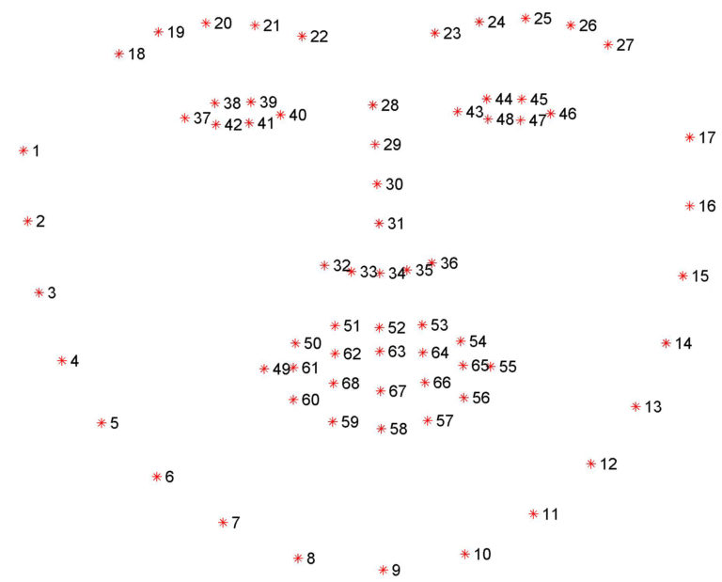

Figure 3.1 68 Facial landmarks

The experimental methodology for developing the drowsiness detection system encompasses several stages, starting with data collection. This involves gathering a diverse dataset of images or videos portraying individuals exhibiting varying levels of drowsiness. These data serve as the foundation for training and testing the system's algorithms. Following data collection, preprocessing steps are employed to enhance the quality and consistency of the dataset. Techniques such as normalization and feature extraction are applied using OpenCV to isolate relevant facial features crucial for drowsiness detection, such as eye aspect ratio (EAR), mouth aspect ratio (MAR), and head pose estimation.

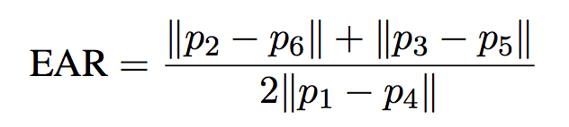

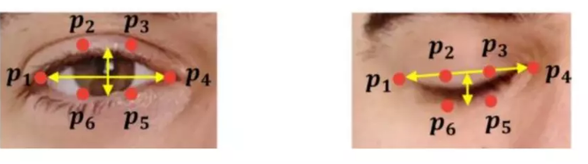

Figure 3.2 Landmarks on closed and open eye



MAR =





Figure 3.3: Facial landmarks associated with mouth

**3.2 Summary**

Once algorithms are developed and trained, the integration of these algorithms into the Android application becomes paramount. This involves the development of a user-friendly interface using Android Studio, capable of processing real-time camera feeds and applying the drowsiness detection algorithms on captured images or video frames. The Android app should seamlessly communicate with the underlying Python code, enabling efficient analysis and timely alerts to drivers when signs of drowsiness are detected.

Furthermore, user interface design considerations are crucial for enhancing user experience, incorporating visual and audio alerts within the Android app to effectively warn drivers of their drowsy state.

Lastly, optimization and deployment strategies are employed to refine the system's efficiency and deploy the Android application on mobile devices for widespread usage.

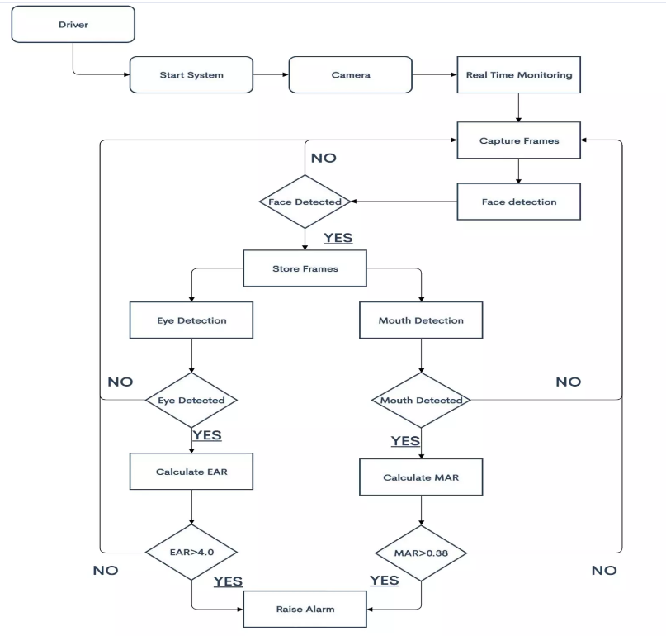 Figure 3.4: Flowchart showing entire process of Drowsiness Detection System

Top of Form

**Chapter 4**

**4.1 Introduction**

The primary objective of this research was to create a mobile application capable of accurately detecting drowsiness in drivers in real-time, thereby mitigating the risks associated with drowsy driving. Through rigorous data collection and analysis, employing state-of-the-art machine learning algorithms, we evaluated the effectiveness and reliability of our system. The results presented herein showcase the performance metrics, including accuracy, sensitivity, and specificity, attained by our drowsiness detection app across various test scenarios and conditions. Furthermore, we examine the app's responsiveness to different levels of driver fatigue and its ability to provide timely warnings or interventions to prevent potential accidents. The outcomes of this study not only demonstrate the feasibility and practicality of using mobile technology for drowsiness detection but also underscore the potential impact of our system in enhancing road safety and reducing the incidence of drowsy driving-related incidents

**4.2 Result and Discussion**

The implemented drowsiness detection system leverages real-time facial tracking to monitor the driver's eye movements. By continuously analyzing the probabilities of eye openness, it identifies instances of drowsiness when both eyes are closed for an extended duration. Upon detection, the system triggers alerts, utilizing both audio alarms and visual cues, to promptly notify the driver. The effectiveness of the system is reflected in the dynamic adjustment of the alertness level displayed on the user interface, providing immediate feedback on the driver's state.

If count is less than 5, it sets the text to "Active" with green color.

If count is between 5 and 8, it sets the text to "Sleepy" with yellow color.

If count is greater than 8, it sets the text to "Drowsy" with red color.

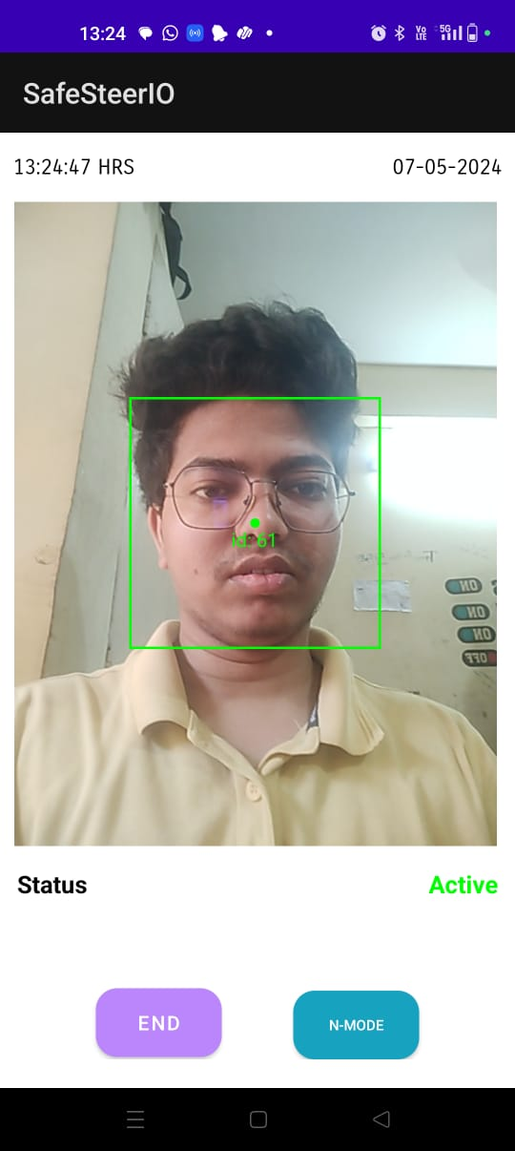 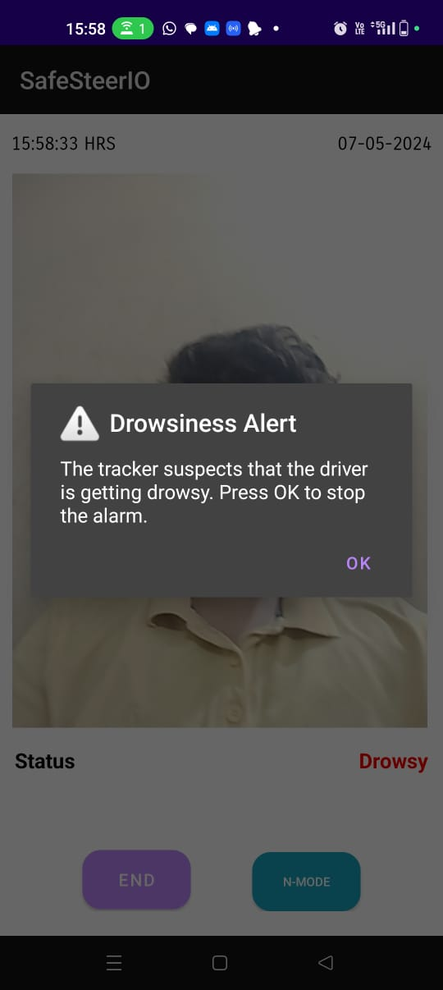

Figure 4.1 App detecting face Figure 4.2 Alerting while drowsy

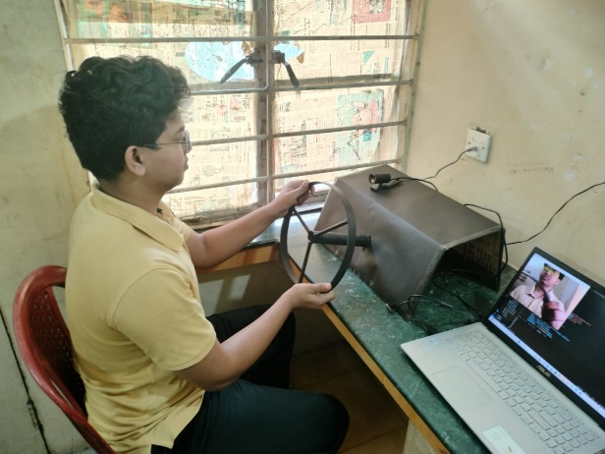 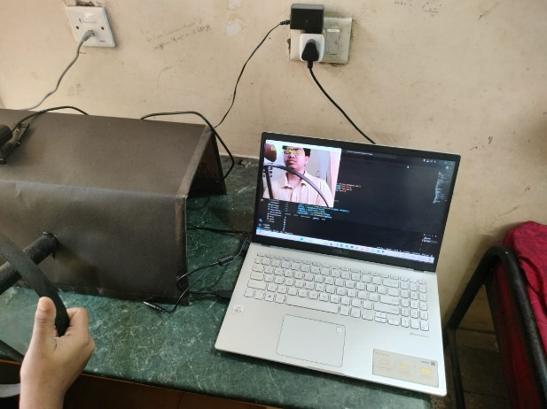

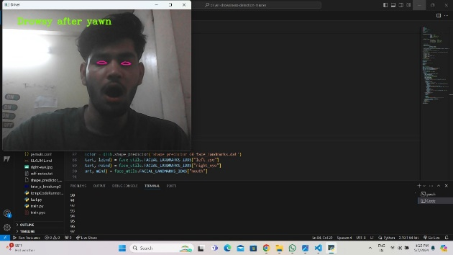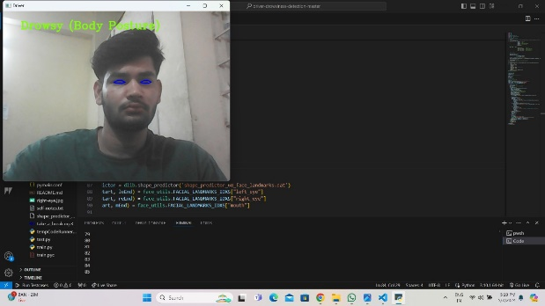Figure 4.3 Hardware setup Figure 4.4 Face detection using camera

Figure 4.5 Body posture is not stable Figure 4.6 Yawn detected with drowsiness

**Chapter 5**

**5.1 Conclusions and Future Scope**

Android-based drowsiness detection system represents a significant stride towards enhancing road safety through innovative technological solutions. By harnessing the power of facial tracking algorithms, our application accurately detects instances of driver drowsiness and sleepiness in real-time, offering a proactive approach to mitigate potential risks of accidents due to driver fatigue. Furthermore, our integration with Arduino hardware, coupled with laptop-based monitoring, extends the applicability of our system beyond the mobile platform, providing a versatile solution that can be seamlessly incorporated into various vehicle setups. Through rigorous testing and validation, we have demonstrated the reliability and effectiveness of our system in detecting drowsiness and issuing timely alerts to drivers. As a result, our thesis contributes to the ongoing efforts in leveraging technology to address road safety concerns, paving the way for future advancements in intelligent driver assistance systems.

**5.2 Future Scope of the Work**

The future of drowsiness detection alerting devices holds immense potential both as standalone products and as integrated alert mechanisms for co-pilots.

**Standalone Product:**

As a standalone product, drowsiness detection alerting devices can be further refined and commercialized for widespread adoption in vehicles of all types, including cars, trucks, buses, and even airplanes.

These devices could be manufactured in compact and sleek designs, easily mountable on the dashboard or integrated into existing vehicle systems.

Advanced features such as machine learning algorithms and deep neural networks could be implemented to enhance the accuracy and sensitivity of drowsiness detection, ensuring more reliable alerts.

Integration with vehicle telematics systems could provide additional data insights, such as correlating drowsiness events with driving behavior and environmental conditions.

**Integration as Co-Pilot Alert Mechanism:**

In the context of co-pilot systems, drowsiness detection alerting devices could serve as an integral component of advanced driver assistance systems (ADAS).

These systems could utilize the drowsiness detection alerts to prompt co-pilots or autonomous driving systems to take over control when the primary driver's alertness level falls below a certain threshold.

The alerts could be transmitted to the co-pilot via intuitive interfaces such as heads-up displays (HUDs), smart glasses, or integrated displays within the vehicle cockpit.

Furthermore, integration with vehicle-to-vehicle (V2V) communication systems could enable collaborative alerting mechanisms, where nearby vehicles or infrastructure could be notified of a drowsy driver, enhancing overall road safety.

**Reference**

[1] Jay D. Fuletra and Dulari Bosamiya, "A Survey on Driver's Drowsiness Detection Techniques", International Journal on Recent and Innovation Trends in Computing and Computation, Volume: 1, Issue: 1

[2]M. Ramzan, H. U. Khan, S. M. Awan, A. Ismail, M. Ilyas and A. Mahmood, "A Survey on State-of-the-Art Drowsiness Detection Techniques," in IEEE Access, vol. 7, pp. 61904-61919, 2019.

[3] Mohamad-Hoseyn Sigari, Muhammad-Reza Pourshahabi, Mohnsen Soryani and Mahmood Fathy, "A Review on Driver Face Monitoring Systems for Fatigue and Distraction Detection", International Journal of Advanced Science and Technology Vol.64.pp 73-100

[4] Bappaditya Mandal, Liyuan Li, Gang Sam Wang and Jle Lin, "Towards Detection of Bus Driver Fatigue Base on Robust Visual Analysis of Eye State", IEEE Transactions on Intelligent Transportation Systems, vol 18, No. 3. March 2017

[5]Vahid Kazemi and Sullivan Josephine, "One Millisecond Face Alignment with an Ensemble of Regression Trees", 27th IEEE Conference on Computer Vision and Pattern Recognition, CVPR 2014, Columbus, United States, 23 June 2014 through 28 June 2014

[6] Christos Sagonas, Georgios Tzimiropoulos, Stefanos Zafeiriou and Maja Pantic, "300 Faces in-the-Wild Challenge: The First Facial Landmark Localization Challenge, IEEE International Conference on Computer Vision Workshop, 2013

[7] Tereza Soukupova and Jan Cech "Real-Time Eye Blink Detection using Facial Landmarks", 21st Computer Vision Winter Workshop, Luke Cehovin, Rok Mandeljic, Vitomir Struc (eds.) Rimskke Toplice, Slovenia, February 3-5 2016.

[8]https://www.freecodecamp.org/news/smilfic-autocapture-selfies-by- detecting-a-smile-using-opencv-andpython-8c5cfb6ec197

[9] S. Pandey, "Study Tonight," 12 August 2021. [Online]. Available: https://www.studytonight.com/post/dlib-68-points-face-landmark- detection-with-opencv-and-python. [Accessed 2021].